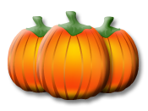
October
Snack Person | Tuesday | Thursday
Abby | 3  Wear something white to school. | 5  Bring in a white toy.
Ava | 10  Find something red around the house and bring it in.  ** Field Trip $$ Due** | 12  Fire Safety- Dousman Fire Department will visit us at school! Wear red today!
Victoria | 17  Field Trip to Cozy Nook Farm!  Wear something orange. | 19  Find something orange around the house and bring it in.
Kamden | 24 **Parent Teacher Conferences- before and after school**  Bring something pink. | 26 **Parent Teacher Conferences- before and after school**  Bring something purple.
Jack/ Oliver | 31  Fall Songs and Party- parents stay for first 20 minutes. Costumes optional. | Nov. 2  Bring in or wear something black.

