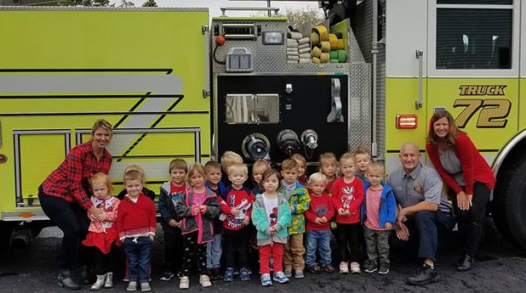

3K

Fun

In

Nov.

**Recap of October**

We’ve had so much fun getting to know your children! The class has done an amazing job settling into our circle time, centers, free play, outdoor play, and snack time routines at school. What a wonderful class we have!

On October 14th we visited the Cozy Nook Farm. Despite the rain, we loved riding the hay wagon, climbing in the straw, feeding hay to the teenage cows, and finding our perfect pumpkins and gourds, Thank-you to all of the parents who joined us for this field trip! It is always wonderful having so many chaperones.

Remember:

There is no app to replace your lap. Read to your child!

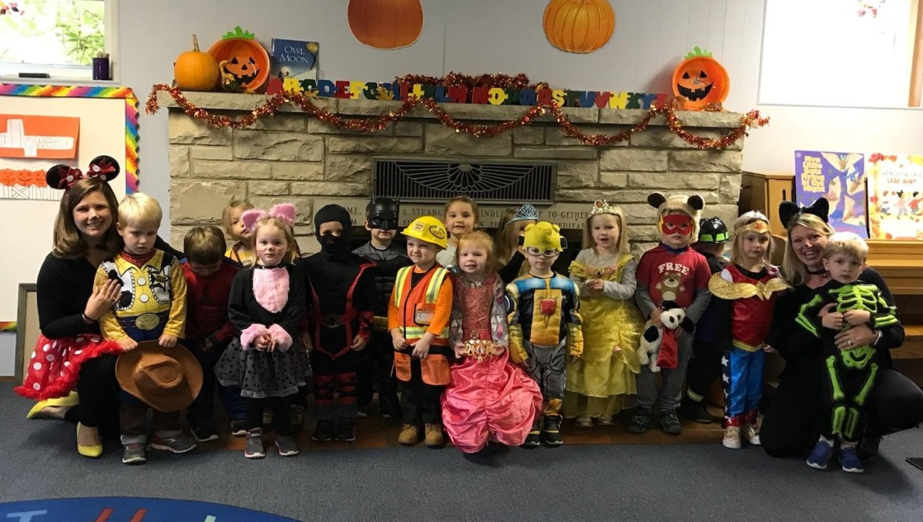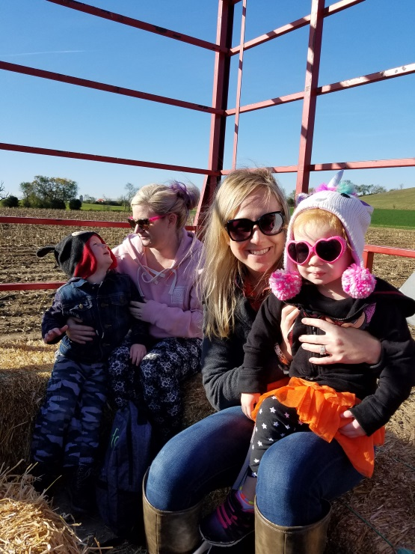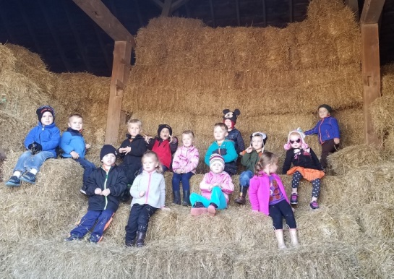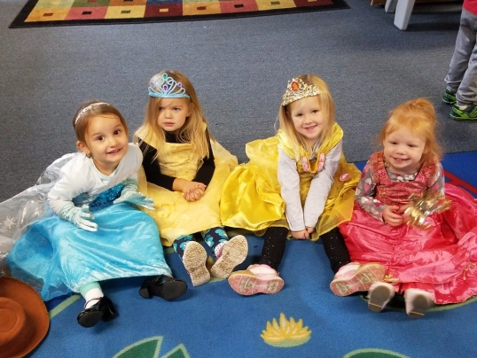

Important Upcoming Dates  
~ Please note **that tuition is due** on **Tues., Nov.14th .** Prompt payment would be greatly appreciated. Thank-you!

~ On **Thursday, Nov. 16th** we will celebrate **Thanksgiving** by talking about families and all that we are thankful for. We will also collect canned goods for the Kettle Moraine Food Pantry on that day. Thank-you for helping with this project!. We would like to wish you and your families a very Happy Thanksgiving!  
~ There will be **no school on Tuesday 11/22 or Thursday, 11/24.**

Thank you!  
Thank you, parents, for all of your help making our Cozy Nook field trip a success! We really appreciate all of our awesome chaperones!   
  
Outside Clothing

It is that time of the year to dig out the warmer coats, hats, and mittens.  Please remember to send these items with your child, as it can be very windy on the playground and those little hands and ears get cold quickly.  Please label everything with your child’s name. We’ll try to keep going outside for as long as we can before it gets too cold. Thank you!