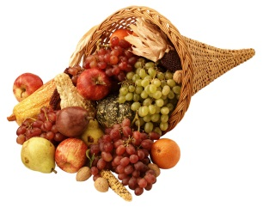
November

Snack Person | Tuesday | Thursday
Ariana | 7  Bring something silver. | 9  Bring something gold.
Henry | 14 **Tuition Due**  Bring something brown. | 16  Bring a picture of something you’re thankful for and a canned good for the food pantry.
 | 21  No School- Happy Thanksgiving! | 23  No School- Happy Thanksgiving!
Parker | 28  Bring in something shaped like a square. | 30  Make a square in a creative way.

On Thursday, November 16th we will celebrate Thanksgiving by talking about our families, being thankful, and sharing. Please have your child bring at least one canned good to donate to our local food pantry. Thank you!
Happy Thanksgiving to all!!

