Monthly Theme:  Fall/Thanksgiving | Snack Person | Monday | Wednesday | Friday
Letter: Ll | Kenna | 6  NO SCHOOL | 8  Bring in something little | 10  Bring in something that starts with l
Letter: Ff | Caleb | 13  Make a fish and color it | 15  Write down a word that begins with f | 17  Bring a flashlight to school. Please label with your child’s name.
 | Forrest | 20  Bring a canned good to donate to the Kettle Moraine Food Pantry. | 22  NO SCHOOL | 24  NO SCHOOL  Happy Thanksgiving
Letter: Nn  Star of the Week: Brooks | Brooks | 27  Bring something noisy to school | 29  Write a word that begins with n | Dec. 1  Do something nice for someone today
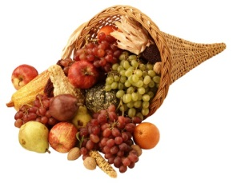
November

