4K

Fun

In

Nov.

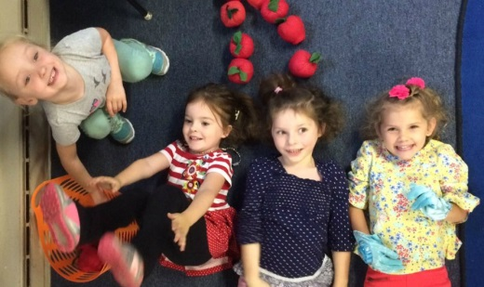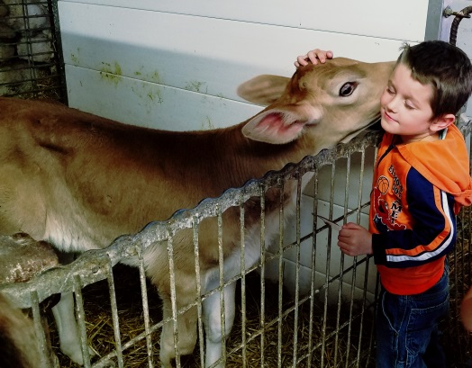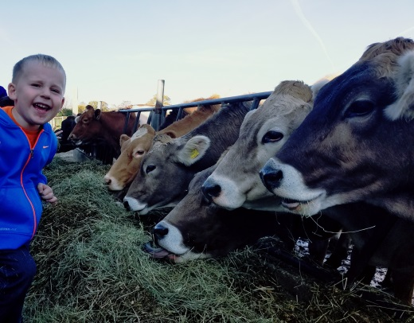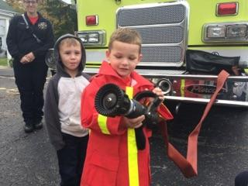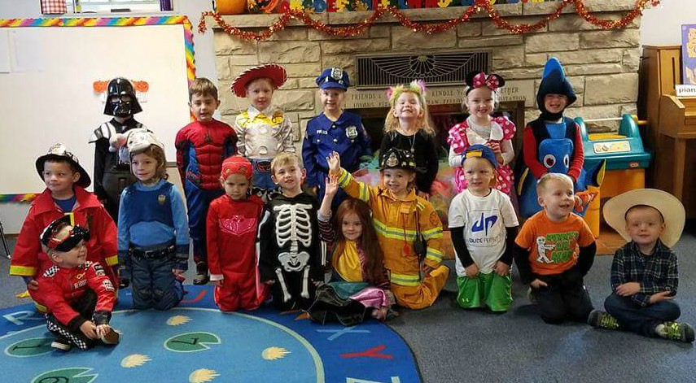

Extra Clothes

The extra clothes bag has been working out great for the spills that can happen during our school day.  Just a reminder to update the bag with clothes appropriate for the current season.  Don’t forget to throw in a pair of socks, too.

Outside Clothing

The cooler weather is here and it is time to dig out the warmer coats, hats, and mittens.  Please remember to send these items with your child every day, as it can be very windy on the playground and those little hands and ears get cold quickly.  Please label everything with your child’s name. Once the first snowfall hits, please send snow pants, boots, hat, mittens, etc. in a reusable bag (separate than the backpack) so your child can keep all of his/her belongings together. Thanks so much for your help with this!

Important Dates

A friendly reminder that we do not have school on November 6, 22, and 24.  Have a wonderful Thanksgiving with your families.  We are so grateful for the opportunity to be a part of your child’s life.

Fire Safety and Farm Fun

We had so much fun in October! We really enjoyed our visit with firefighters from the Dousman Fire Stationa few weeks ago! It was so much fun to hold the big hose and climb up into the fire truck and ambulance.

What a beautiful, warm day we had to visit Cozy Nook Farm. We loved riding the hay wagon, learning about crops, feeding hay to the teenage cows, finding our perfect pumpkins and gourds, and eating our snack in a barn. Thank-you to all of the parents who joined us for this field trip! It is always wonderful having so many chaperones.

Thanksgiving Celebration  
 On the Monday before Thanksgiving, 11/20, we will celebrate the holiday by talking about families and all that we are thankful for. We will explain to the children that some families do not have enough food to eat, and that we can help by sharing. We will collect canned goods for the Kettle Moraine Food Pantry on that day (11/20). Thank you for helping with this project. We would like to wish you and your families a very Happy Thanksgiving!

3K

Fun

In

Sept.