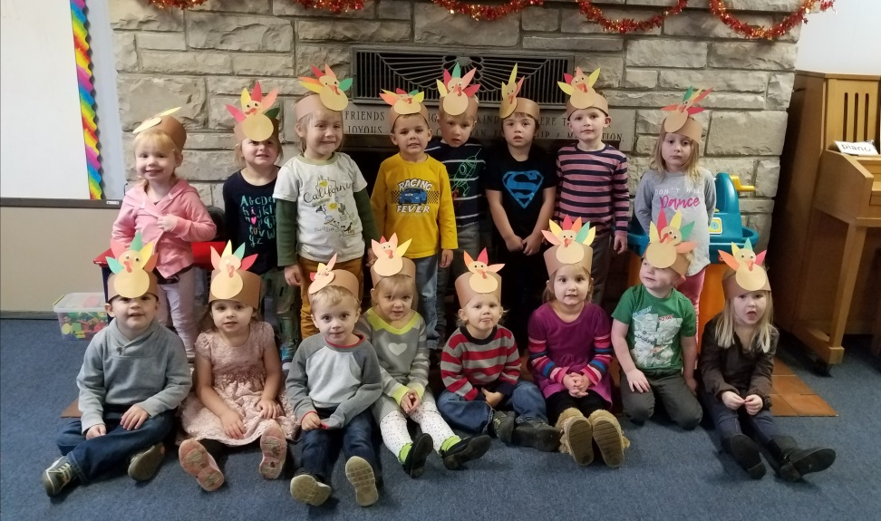

3K

Fun

In

Dec.

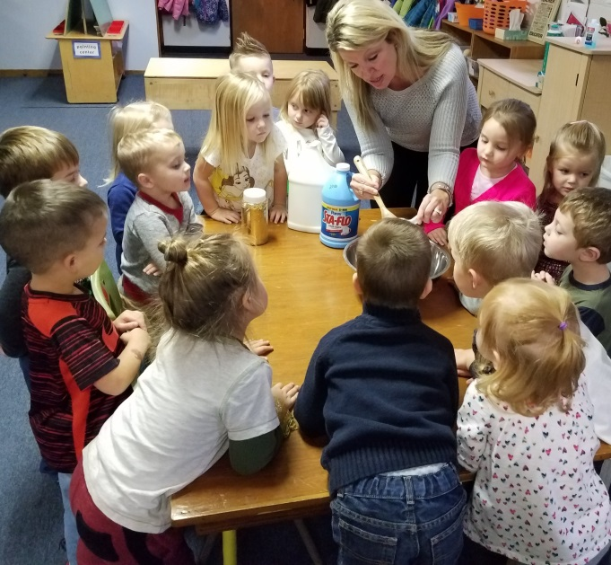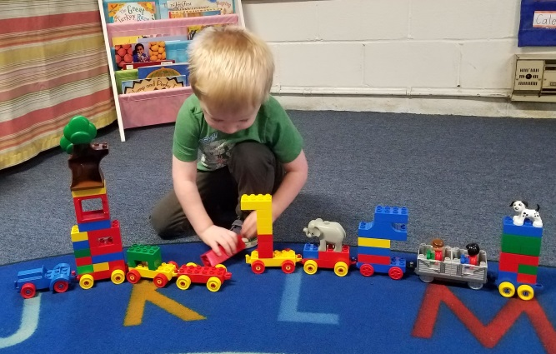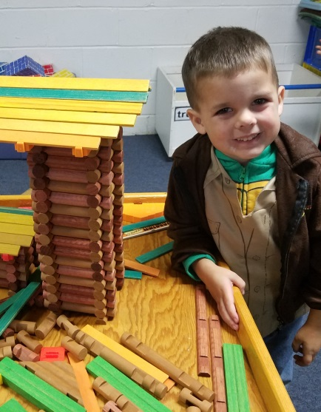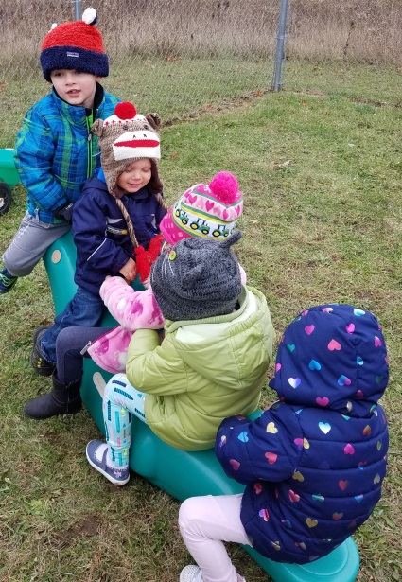

Winter Program

December will be an exciting month for us at Kettle Moraine Preschool. The children will be working on special holiday art projects and Christmas songs and activities. We are looking forward to celebrating Christmas with you at our party on Thursday, December 21st All children should be brought to school at our usual 9:00am start time, and then parents are invited to join us at 10:45 am to enjoy hearing our wonderful Christmas songs. If you would be willing to contribute a small plate of cookies or snacks for after the Christmas program, we’d appreciate it! Please look for a sign-up sheet in the next few weeks. Our party should be over at our normal dismissal time, 11:30.

Thank you!

Thank you to all for your donations to the food pantry! It’s always heartwarming to see these little ones so excited to give generously!

You will notice a wishing tree set up with ideas for supplies and other items that we could use in our classroom. Thank you so much for your continued support! We sincerely appreciate any donations- the kids will enjoy using any new supplies ☺

We wish your family a wonderful holiday season and a happy, healthy new year! We can’t wait to hear all about your break when we return to school on Thursday, January 4th, 2017!

3K

Fun

In

Sept.