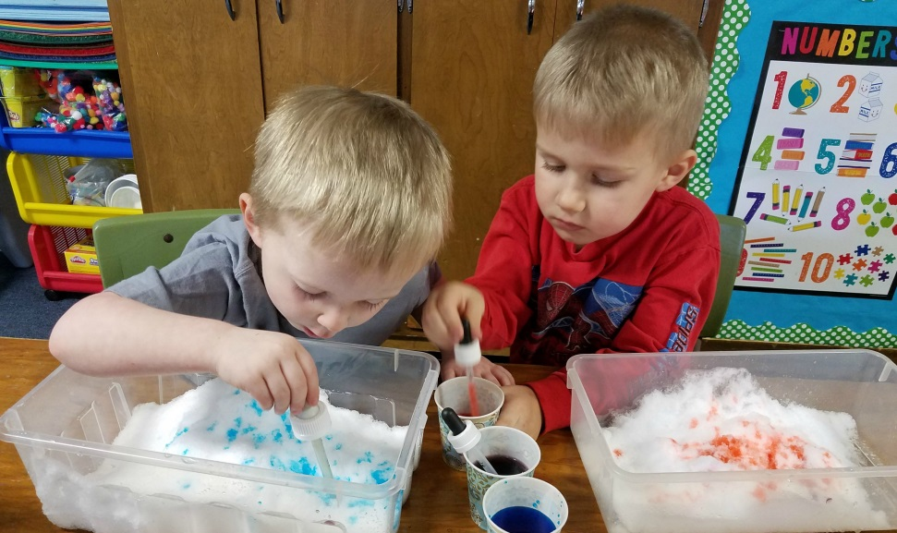

3K

Fun

In

February

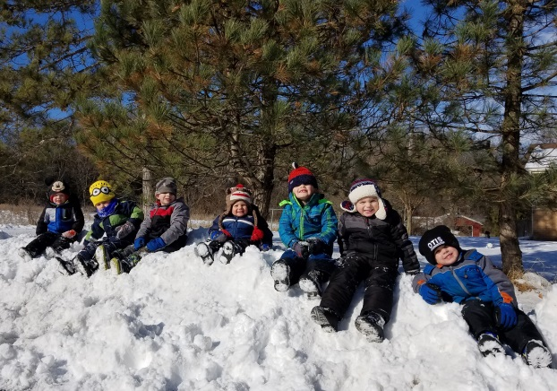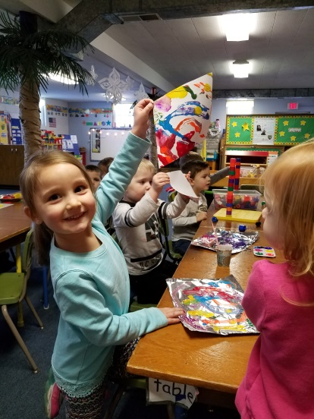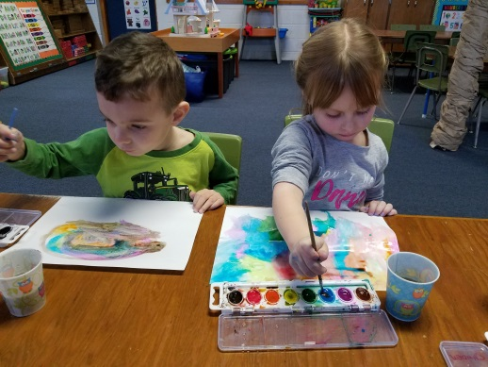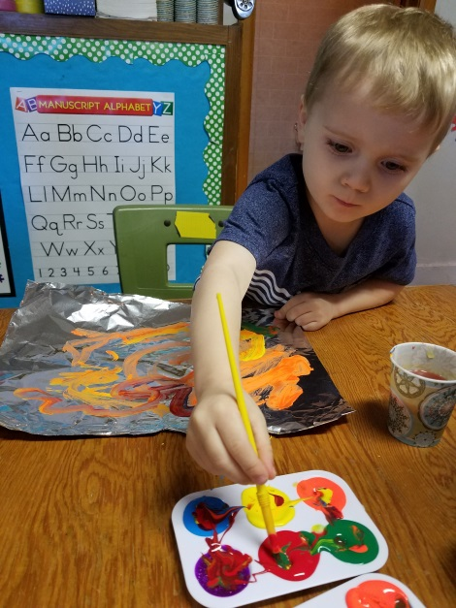

Valentine’s Day Party  
Our class Valentine’s Day party will be held on Tuesday, February 13th. The children may bring in 19 valentines on that day. You can help your child sign their name on each card, but please do not write friends’ names on the envelopes or cards. This makes distribution much, easier ☺

Report Cards  
You received your child’s report card earlier in January. We just want to reiterate that each child is an individual and will develop skills at a different pace than others. Our hope is for students to be in the developing or secure range for the various skills on the report card before moving on to 4K. Our assessments are a great tool for us to help individualize our instruction and best meet each child’s needs. Please see the attached note and resources about name writing.

2018-2019 School Year  
We would love for your child to join us at Kettle Moraine Preschool again next year. Registration for 4K for the 2018-2019 school year has begun. You can register in person at on the KMSD 4K website. Even if you already filled out our yellow Registration Form, be sure to still apply for 4K through the school district in order for tuition to be paid by the district. Open enrollment for out of district students begins on February 5th and closes on April 30th. You can visit the Department of Public Instruction’s website at www2.dpi.state.wi.us for more information about the open enrollment process. If you have any other questions, we would be happy to help you in any way. If you plan to have your child join us for another year of 3K, please just let us know so that we reserve your spot! Space is filling up fast! Please spread the word about our school to your family, neighbors and friends who may have a 3K or 4K age child!

3K

Fun

In

Sept.