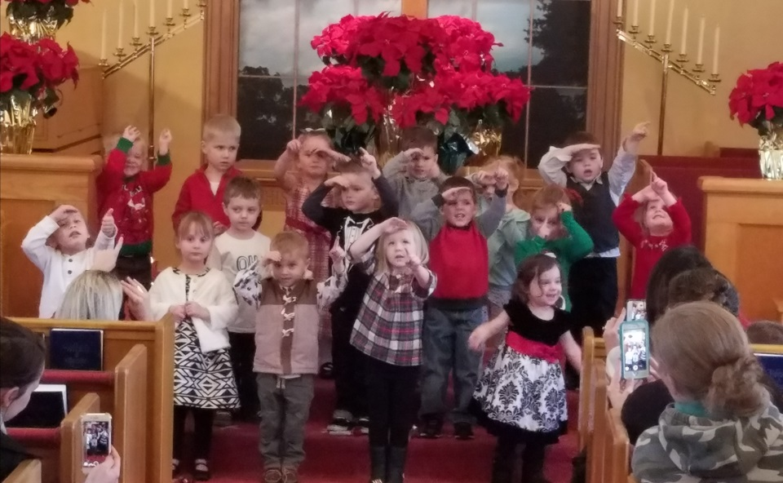

3K

Fun

In

January

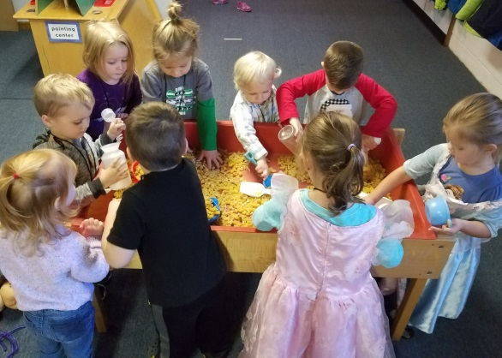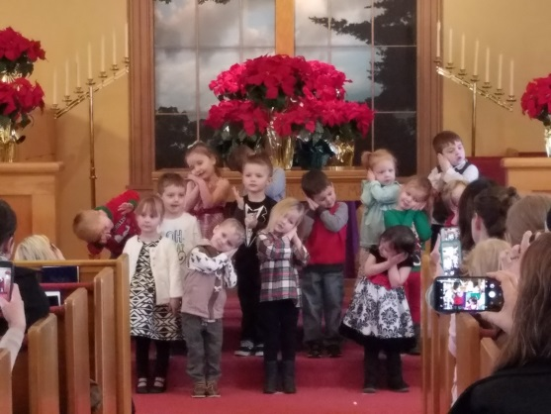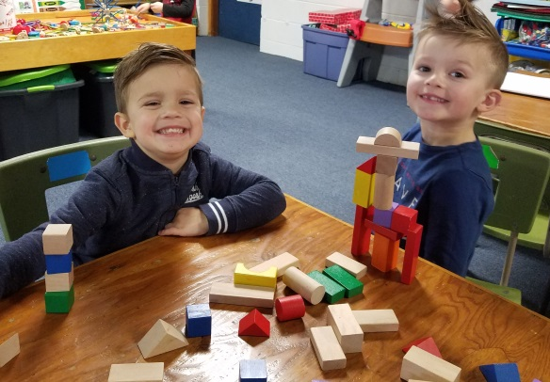

Welcome Back and Happy New Year!

Welcome back! We hope you had a wonderful holiday break with your family! We had a great time at our Christmas party and we hope you did too! We couldn’t be more proud of how well your children performed! They did an EXCELLENT job! We thank you for the generous Christmas gifts as well! Thank you to all who contributed to our Wishing Tree. We really appreciate your generosity!  
As we start this brand new year, we want to again thank-you for entrusting your children into our care. We are excited about the fun activities ahead!  
4K Q & A  
Several parents have had questions regarding the 4K enrollment process. I will be available to answer questions and walk you through the process on **Thursday, 1/11 from 9-9:15.**

Looking Ahead  
We would love for your child to join us at Kettle Moraine Preschool again next year. If you plan to have your child attend next year, please fill out and return the attached registration form. This will help us greatly as we plan for next year and will also secure your child’s spot in your desired class. Here are a few other important upcoming dates:   
**Kettle Moraine School District 4K Parent Information Night**: Thursday, 1/18/18 at 6:00, Wales Elementary School library.  Lots of information about Kettle Moraine School District's 4K program and the enrollment process. **Families residing within Kettle Moraine School District**: The district 4K Application Window begins Tuesday, 1/23/18. Registration will be done online at https://www.kmsd.edu/Page/362  **Kettle Moraine Preschool Open House Day**: Want to see our 4K class in action?  Schedule an appointment to come observe on Wednesday, 1/24/18 between 9-3.   
**Families residing outside of the Kettle Moraine School District**: the State of Wisconsin Open Enrollment window for the 2018-2019 school year is February 5th- April 30th 2018. For more info and for the Open Enrollment application, visit https://dpi.wi.gov/open-enrollment

3K

Fun

In

Sept.