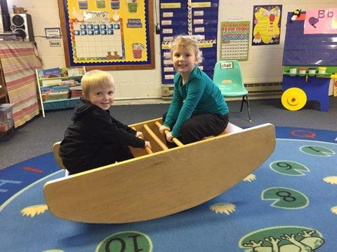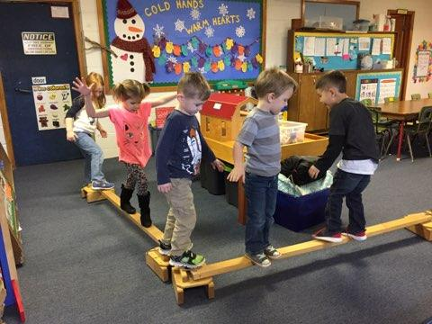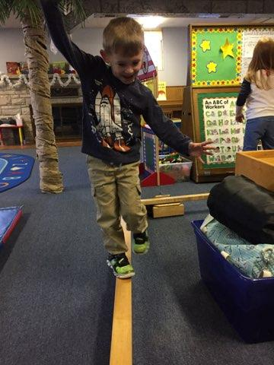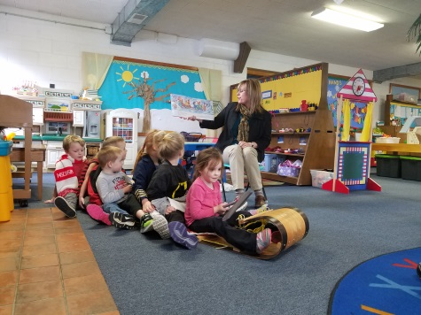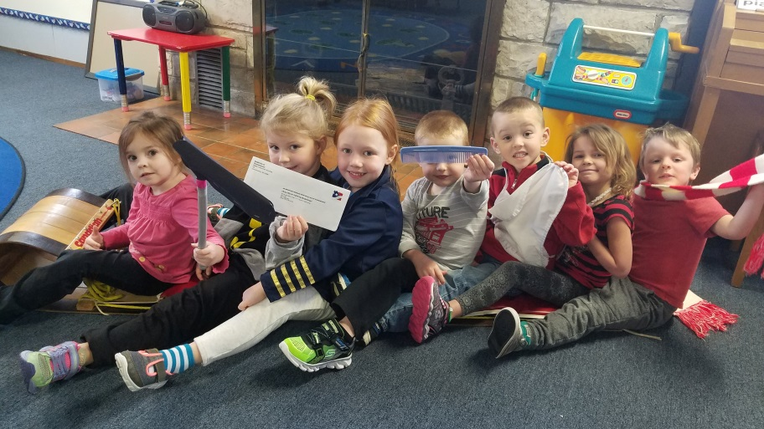

4K

Fun

In

February

**Valentine’s Day Celebration**  
  
Our class Valentine’s Day celebration will be held on **Wednesday, February 14th.** The children should bring in 17 valentines on that day. Your child can sign his/her name on each card, but please do not write friends’ names on the envelopes or cards. This makes handing out valentines easier.   
  
Your child may bring a special treat on this day, but it is not required. We ask that you send individually wrapped valentine treats. As a friendly reminder, we cannot serve homemade treats. We suggest no desserts in lunches on this day, as the children will have plenty to choose from in their valentine bags. Thank you so much for helping us make this day special!

**Book Bags**

We are excited to now have book bags that your family can check out. There is a book and activity in each bag that you can do with your child. Each bag has a number on it to write down on the check out/in form. Please let us know if you find any items missing or books damaged, so that we may fix it before the bag gets checked out again. We hope you enjoy this time with your child!

**Dr. Seuss Week**

We will be doing a variety of fun activities the last week of Feb. as we celebrate the birthday of Dr. Seuss. On Friday, March 2, we will be reading the book, Green Eggs and Ham. We are looking for volunteer(s) to cook green scrambled eggs. This can be prepared at 9am using the kitchen upstairs. All supplies will be provided. We will start our day off with a story and taste testing green eggs and ham. Thanks for your help.