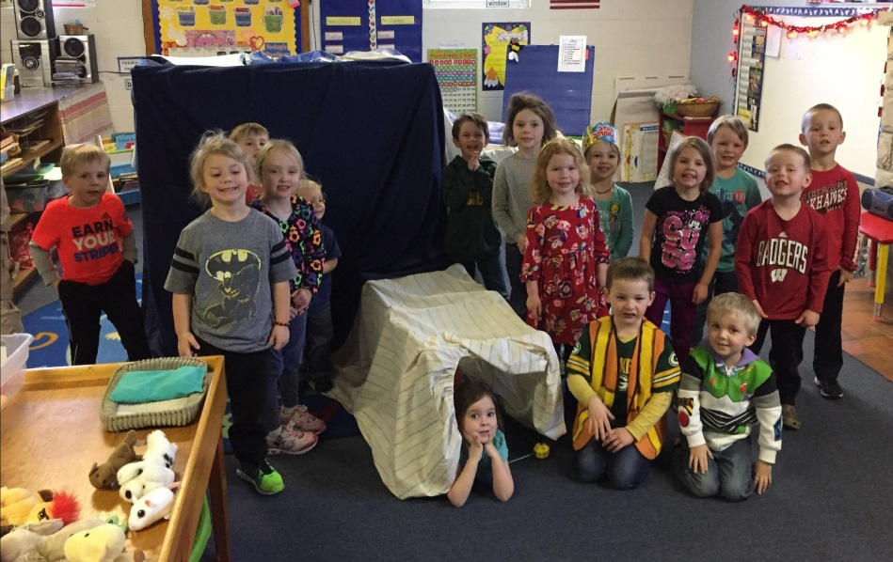

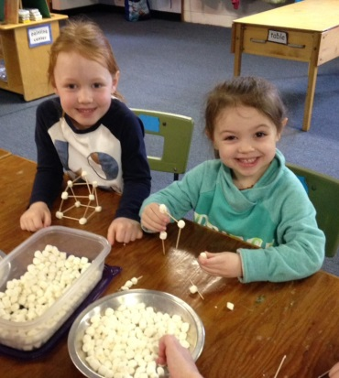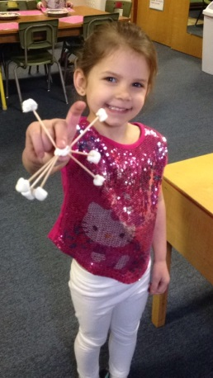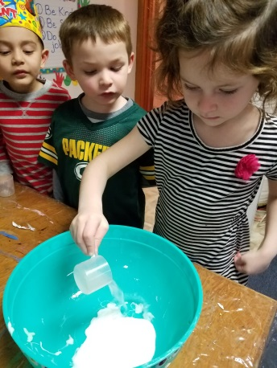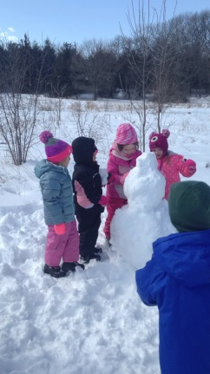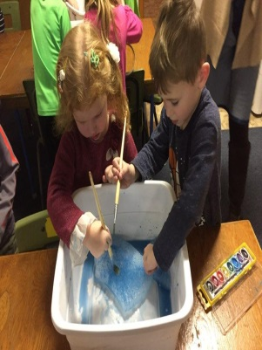

**Fun with Dr. Seuss**

We have been having fun celebrating the author Dr. Seuss. The anticipation of trying green eggs and ham has been fun. We hope your child is learning to love books as much as we do. Oh, the places you can go in a book! This age is a great time to visit our local libraries. We are so fortunate to have so many around us. Most libraries issue library cards to any child who can sign his/her name. The best part is this is FREE! The Delafield Library even has a time your child can sign up to “read” to Gracie the dog. At this age the children can picture read the story or retell in their own words. The best part is that Gracie is always ready to listen.

**Passing the Word Along**

Please help us get the word out about KM Preschool’s 3K $ 4K programs! If you know of anyone looking for 3 & 4-year old programs for next year, please share your experience. Your referral is the biggest compliment you can give us.

**Dino-mite Dad’s Night**

Calling all 4K Dads on Monday, March 5th from 6-7pm to spend some special time with your 4K child. (Sorry, no siblings just one-on-one time with your 4K child) It is “D” week and our theme is dinosaurs. Come sing, play, create, and eat a snack with your child. If you are unable to attend, your child may invite a grandfather, uncle, or other special man in their life to attend.

**Spring Field Trip Save the Date**

We will be going to Retzer Nature Center on Friday, April 27. This date is **not** on the school calendar that you received at Open House. We will leave at 10am and return at 2pm. We will be seeing a Planetarium Show, eat a picnic lunch, and then have a special program with a naturalist. A permission slip with more details will go home when the date gets closer. Parents are welcome to join us for this field trip. Sorry, no siblings.

4K

Fun

In

March

3K

Fun

In

Sept.