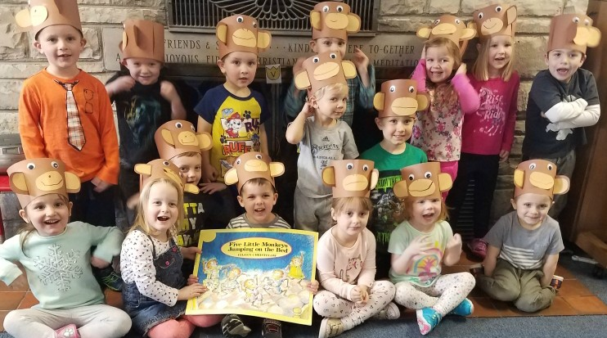

3K

Fun

In

May

All School Picnic  
 We will be having our end of the year picnic for both our 3K and 4K classes at Ottawa Park (corner or Hwy 67 and Hwy D) on **Thursday, May 24th**. The picnic will start at **11:00 a.m**., and everyone is welcome- siblings, moms, dads, grandmas, grandpas! Please look for a sign-up sheet in the next couple weeks to bring a dish to share and/or to help run the games. We really appreciate your help! We will also be asking for an estimate of how many people you expect to attend from your family so we can plan accordingly.   
Special Dates  
On our last day of school, **Tuesday, May 22th**, we will be celebrating all of the children with summer birthdays in late May, June, July, August, or early September. Feel free to provide a birthday treat on that day. Parent Teacher Conferences will be on **Tuesday, May 15th** and **Thursday, May 17th** before and after school. Look for a sign-up sheet soon!

End of the Year!  
Can you believe that our school year is almost over? It has been a wonderful year, and we have sincerely enjoyed learning alongside your children. It has been a joy to watch each and every one of them grow and learn over these months. Thank you for entrusting your treasures to us this year! Our last day of school will be on **Tuesday, May 22rd**. We look forward to seeing many of you back at Kettle Moraine Preschool again next year!

Tea Party  
We are planning a special tea party for our 3 year old students and their moms on **Thursday, May 10th**. The children will have some very special songs prepared to share with you, and we will serve tasty snacks and drinks at our tea party. We ask that the children dress nicely that morning, as we will be working on a special surprise that day ☺ We’ll see you at **10:45 am** on that day.

