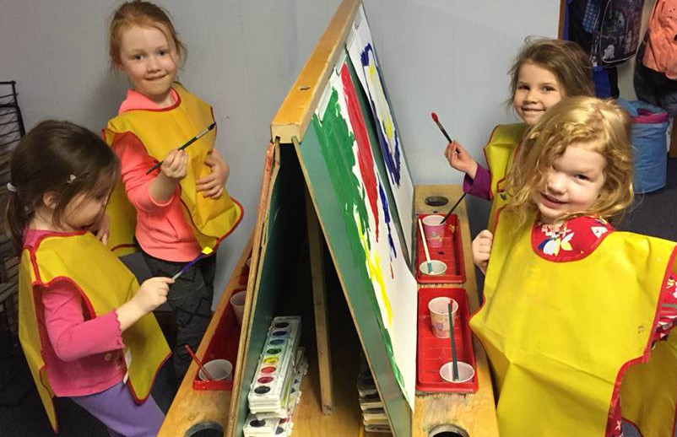

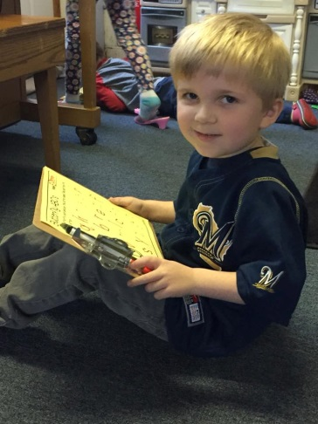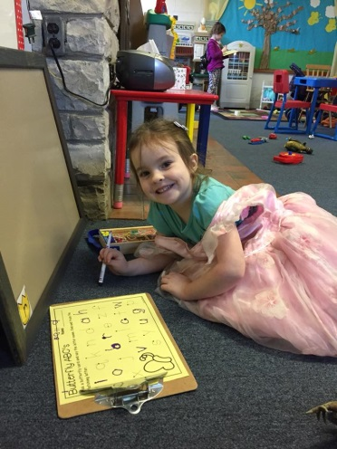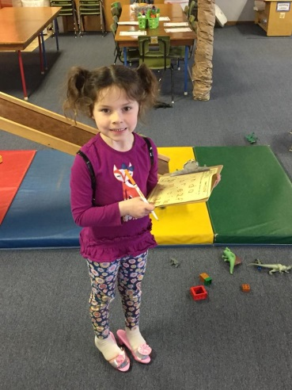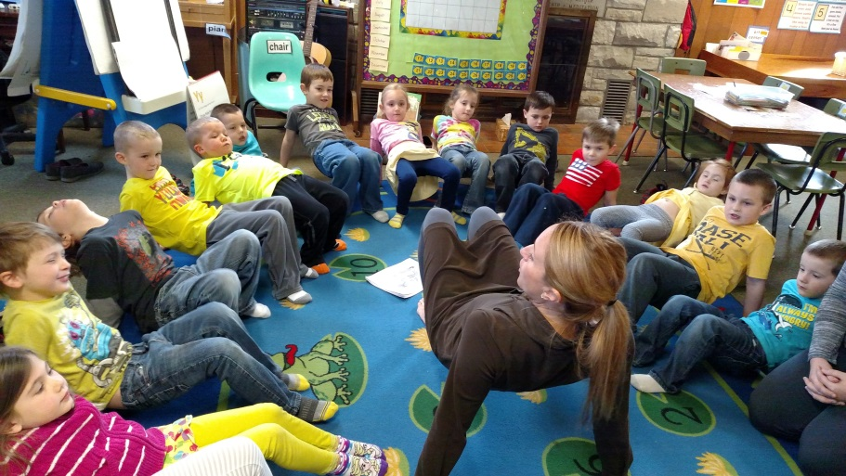

**Conferences**

We look forward to talking with you about your child’s growth this year at parent teacher conferences. We will be meeting with parents before and after school on **Friday, May 18 and Monday, May 21.** We will have a sign-up sheet out in May.

.**Thank You!**

Can you believe that our school year is almost over? It has been such a joy watching this community of learners play and grow together this year. If your child will be attending a Kettle Moraine Elementary school for 5K next year, there will be a **5K kickoff** at the elementary school your child will be attending on **Tuesday, May 22 from 5:30 – 6:30.**  This is a wonderful opportunity for your child to see the classrooms and meet the teachers! If your child will be attending KM Explore next year, they will have an open house on a later date. Look for information to be sent to you.

**Help still needed for PALS assessments on May 7-16. Please talk to Mrs. Zell if you can help☺**

**Grandparents’ Day**

Grandparents are welcome to join us on **Friday, May 4 from 9:30-10:30**. We realize not all students have grandparents living nearby, so we welcome any special adult on that day. We will serve a light snack to everyone. Please sign up to bring an item for our snack. We will sing some songs, eat snack together, work on a small craft, and show the grandparents our classroom.

**Songs for Moms**

Please join us on **Friday, May 11th at 2:45** for a special presentation and songs.

**End of the Year Picnic**

Our end of the year picnic for both our 3K and 4K classes will be held at Ottawa Park (corner or Hwy 67 and Hwy D) on **Thursday, May 24, 2017**. The picnic will start at 11:00 a.m., and everyone is welcome- siblings, moms, dads, grandmas, grandpas! As we get closer, please look for a sign-up sheet to bring a dish to share, to help run the games, and to get a head count of people. We really appreciate your help in making this picnic special! Our last day of school will be on Wednesday, May 23rd

4K

Fun

In

May

3K

Fun

In

Sept.